MATLAB Assignment # 4

By: Jonathan Lopez

ECE 2010

Section B03; Mailbox # 207


Due 11/17 @ 9PM

MATLAB PROBLEM 4 ECE2010 B19

Relational Operators in MATLAB. Working with MATLAB Scripts
Due Submission Online– Sunday Nov. 17th by 9:00 PM

Preamble
In our fourth MATLAB assignment, we will learn how to

- Use relational operators (<, >, >=, =<, =, ~=) applied to MATLAB variables and arrays.
- Use a powerful function find in MATLAB (type help find for more info)
- Use a powerful function sort in MATLAB (type help sort for more info)
- Use a powerful function rand in MATLAB (type help rand for more info)
- Do basic plotting operations in MATLAB and review MATLAB data storage.

Your Task #1 (40 Points)

Explain what the following commands (operations with arrays or single variables) "mean" by describing the net result of the command. Highlight operations that give equivalent results (if any).

Highlighting the equivalent operation is worth 4pts.

- a = [2 4 6 8 10], index=a>6

- a = [2 4 6 8 10], index=a>6, a(index)

- v = [2 4 6 8 10 12 14 8 16], v(v>=10)=10

- v=[6 -6 20 -20 8 -8 5 -5 14 -14], i=abs(v)>=10;v(i)= 10*sign(v(i))

- v=[1 3 5 7 9 11 13 15], i=find(v==9)

- a = [2 4 6 8 10], i=find(a>6)

- v = [2 4 6 8 10 12 14 8 16], v(find(v>=10))=10

- A = rand(4, 4), surf(A) % try this operation at least twice

- A = rand(4, 4), B = A>0.5

- RGB=imread('street1.jpg'); G=rgb2gray(RGB); G(G>120)=255; imshow(G)

- A = [8 6 2 4 1 5 9], B = sort(A)

1. It takes the newly created array a and uses the index function to compare the number in the array that are greater than 6. Only 2 of them are so it returns 0s for the ones that aren’t greater than 6 and returns 1’s for the one that are greater than 6.

index =

1×5 logical array

0 0 0 1 1

2. It takes the newly created array a and uses the index function to compare the number in the array that are greater than 6. Only 2 of them are so it returns the number that are greater then 6. In this case it would be 8 and 10
a =

2 4 6 8 10

index =

1×5 logical array

0 0 0 1 1

ans =

8 10

3. It take the newly created array v and it takes the numbers in that array over 10 and replaces them with 10

v =

2 4 6 8 10 12 14 8 16

v =

2 4 6 8 10 10 10 8 10

4. It takes the new array V and for the values there are below negative 10 it turns them into -10 and for values over +10 it turns them to +10

v =

6 -6 20 -20 8 -8 5 -5 14 -14

v =

6 -6 10 -10 8 -8 5 -5 10 -10

5. It finds in the array where x absolutely equals 9 and it returns the spot in the array the number is
v =

1 3 5 7 9 11 13 15

i =

5

6. Given the array a we want to find number greater then 6 the find command fins the number in the array and outputs their placement in the array

a =

2 4 6 8 10

i =

4 5

7. It does the same as 3 but it uses the find command for number greater then 10 and replaces them with 10
v =

2 4 6 8 10 12 14 8 16

v =

2 4 6 8 10 10 10 8 10

8. The rand function creates a matrix of random number between 0 and 1 and the variables passed into it are the dimensions. In this case it a 4x4 matrix. It also created a surface plot of the matrix
A =

0.4218 0.6557 0.6787 0.6555
0.9157 0.0357 0.7577 0.1712
0.7922 0.8491 0.7431 0.7060
0.9595 0.9340 0.3922 0.0318

>> matlab4

A =

0.2769 0.6948 0.4387 0.1869
0.0462 0.3171 0.3816 0.4898
0.0971 0.9502 0.7655 0.4456
0.8235 0.0344 0.7952 0.6463

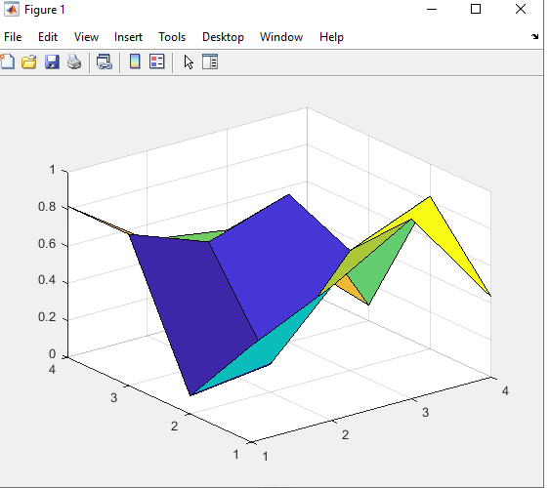

9. Creates a random matrix 4x4 and it takes the number less than .5 and makes them zero and take the number greater than .5 and makes them 1. It outputs a matrix of these 1s and 0s

A =

0.8055 0.8865 0.9787 0.0596
0.5767 0.0287 0.7127 0.6820
0.1829 0.4899 0.5005 0.0424
0.2399 0.1679 0.4711 0.0714

B =

4×4 logical array

1 1 1 0
1 0 1 1
0 0 1 0
0 0 0 0

10.
This is an RGB to grey scale converter for an image. Takes the 255 color code and converts it to grey scale.


11. Arranges the array in numerical order. Lowest to highest.

A =

8 6 2 4 1 5 9

B =

1 2 4 5 6 8 9

Now, from the ECE point of view, we will work with the basic amplifier circuit.

Your Task #2. An amplifier circuit with the negative feedback (40 Points)

Fig. 1 shows an ideal operational amplifier circuit in the closed-loop configuration with negative feedback. The amplifier is powered by a ±6 V dual supply. The input to the amplifier is given by a periodic (sine) function at 60 Hz frequency:

$V_{in}(t)=V_{m}\sin{2}πft, f=60 \text{Hz}, 0s≤t≤0.1s$ (1)

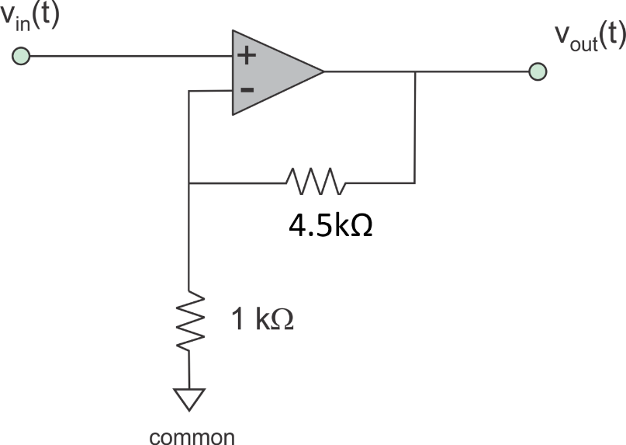

Fig. 1. Operational amplifier circuit.

Your task:
- Determine the gain of the amplifier circuit and generate a MATLAB script that finds and plots both input and output voltage of the amplifier circuit for two values of the input voltage amplitude: and , respectively. (15 Points)
- Make sure you properly initialize the time array (a vector with at least 300 sampling points). (5 Points)
- Make sure you draw both input and output voltage curves on the same plot (the first one should be black, the second one – red). (5 Points)
- Make sure that you properly label your axes and title the figure; (5 Points)
- Introduce grid (use grid on command); (5 Points)
- The time axis must be from 0 to 0.1s (100 ms) and the voltage axis must be from – 10 V to +10 V. If you are unsure how to control figure axes, type help axis in the MATLAB command window and hit ENTER. (5 Points)

Hints:
1. Always use clear or clear all commands at the beginning of your script. These commands will clear the MATLAB workspace for you. Otherwise, some old variables may still be processed. You may use close all command next. This command closes all figures open previously.
2. Define all constants/fixed arrays at the beginning of the script. One way to define the one-dimensional time array in MATLAB is to use t = [0:0.0001:0.1];
3. There are different ways to plot multiple curves on the same figure. One way is to use
hold on;
command first, and then use the plot function for each curve separately. Yet another way is to use a plot function with multiple arguments (x, y, ‘color’ for each curve). Argument ‘color’ may be ‘k’ – black, 'r' – red, etc.
4. In this problem, you might encounter a need to replace function values, which are all greater than, say 6 V, by one fixed value of, say 6 V. Use examples given in Task #1 to program the corresponding operations.
Text of the corresponding MATLAB script (Task #2):
clear all
close all
t = [0:0.0001:0.1];
Vm = 1.5; %Vm = 1.0;
figure
hold on; grid on;
Vin = Vm*sin(2*pi*60*t);
Vo = ((4.5/1)+1)*Vin;
i=abs(Vo)>=6;Vo(i)= 6*sign(Vo(i));
plot(Vin, 'k');
plot(Vo, 'r');
title(' Data for MATLAB #4-- Non-Inverting – Jonathan Lopez')
xlabel(' Time (ms)')
ylabel(' Voltage (V)')
axis([0 1000 -10 10])

Figure (Input and output voltages if in Eq. (1)):
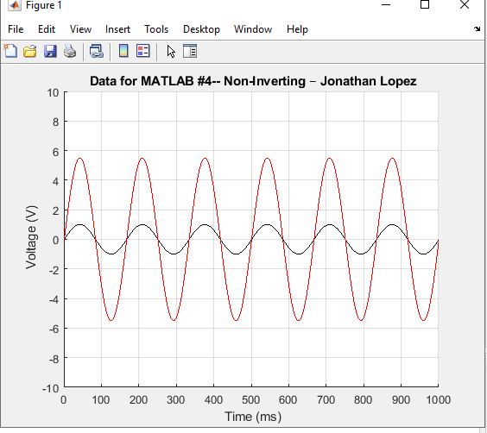
Figure (Input and output voltages if in Eq. (1)):
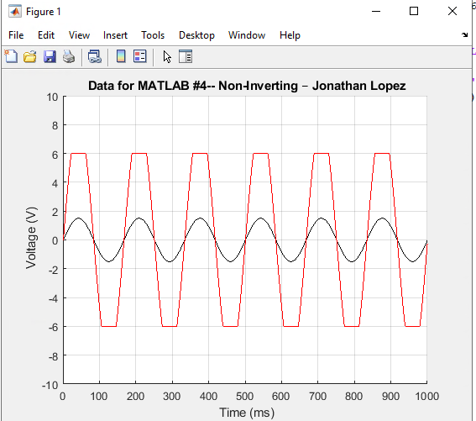

Your Task #3. Another amplifier circuit with the negative feedback (20 Points)

Repeat the previous task for another operational amplifier circuit in the closed-loop configuration with negative feedback shown in Fig. 2. The amplifier is powered by a ±7 V dual supply. The input to the amplifier is given by a periodic (sine) function at 60 Hz frequency:

$V_{in}(t)=V_{m}\sin{2}πft, f=60 \text{Hz}, 0s≤t≤0.1s$ How are the solutions in Tasks #2 and #3 different from each other?

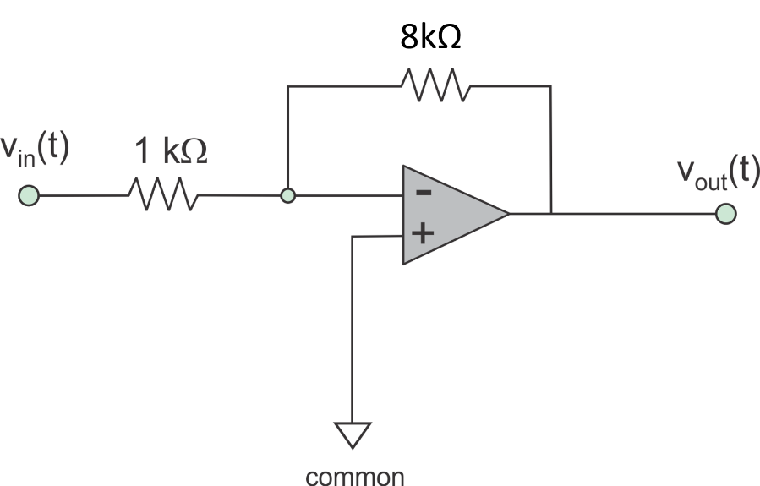

Fig. 2. Another operational amplifier circuit.

Code:

clear all
close all
t = [0:0.0001:0.1];
Vm = 1.5; %Vm = 1.0;
figure
hold on; grid on;
Vin = Vm*sin(2*pi*60*t);
Vo = ((-8/1)*Vin);
i=abs(Vo)>=7;Vo(i)= 7*sign(Vo(i));
plot(Vin, 'k');
plot(Vo, 'r');
title(' Data for MATLAB #4-- Inverting – Jonathan Lopez') % Put your name here
xlabel(' Time (ms)')
ylabel(' Voltage (V)')
axis([0 1000 -10 10])

Figure (Input and output voltages if $V_{m}=1.0 V$ in Eq. (1)):
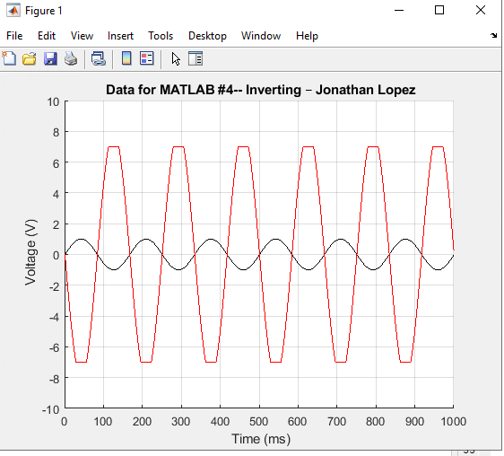

Figure (Input and output voltages if in Eq. (1)):
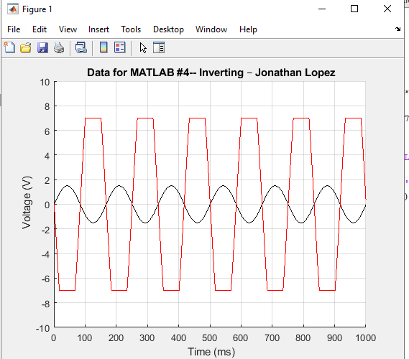

How are the solutions in Tasks #2 and #3 different from each other?
Task 2 is using a Non-Inverting Op Amp configuration. Which uses a different gain formula than task 3 which uses an Inverting Configuration of the Operational Amplifier. Non inverting = ((R2/R1)+1) while the Inverting one is (-R2/R1). Therefore, the graphs will look different. When Vin is negative Vo will be positive on a Inverting amplifier circuit. And in a non-inverting amplifier circuit when Vin is positive Vo is positive.

There is a MATLAB help session this coming Sunday from 7 PM to 9 PM in AK317a (the lab room).

